New Wafer Attachment Technology for Sawing

Diamond Touch Technology Inc offers solutions for the larger semiconductor marketplace. This includes sawing technology, and scribing and breaking technology. This capability extends beyond semiconductor wafers to various other electronic materials and stacked structures. Their equipment and support materials address the previous limitations in this arena.
The Diaframe is one of these unique solutions that extends the capabilities of the wafer mounting system and includes the capability to break on a scribe cut or scribe line without touching the top surface of the wafer. The patented design provides rapid simultaneous bilateral fracture of the substrate on the scribe line propagating from the center to the edges and in a manor that produces a repeatability not previously achievable in the scribe and brake process. When the saw cut is changed to a scribe cut, the sawing time is reduced because faster, bi-directional feed is possible when the blade doesn’t have to cut thru the die and into the blue attachment tape. Bottom side chipping and adhesive gumming of the wheel are eliminated. Our saw technology and the Diaframe break technology combine to produce a uniform die size with a repeatable shape. The repeatable size of the lip on the bottom often improves the die attach pull test strength and the Diaframe stretches to separate the die so they can be picked from the Diaframe by the die bonder.
The Diaframe uses a new proprietary adhesive that improves on the performance expected from the standard blue tape. In theory the blue tape allows attachment of the wafer with complete bonding to the bottom side, strong adhesion during the saw and cleaning phase including shipping and storage and then much lower adhesion for the die pickup after expansion of the film to separate the die.
The limitations come in the success of attachment, the strength of the adhesive during sawing (including de-lamination along the edges of the die during cutting) and maybe of greatest concern, the inability to reduce the adhesion to remove the individual die for die placement especially after more than a few days storage for shipping and setup of the bonder. For some applications the tiny amount of silicone oil released by the tape with the UV release can leave contamination that can affect the die.
Diamond Touch considered all of these factors when designing a new adhesive system for the Diaframe. Their adhesive creates a greater bond strength than achievable with any version of the blue tape. The Diaframe and adhesive system show less die squirm than blue tape. The UV release of this adhesive exhibits more range than with blue tape. The extreme is adhesion reduction to levels that allow the die to fall off the tape for bulk processing of diodes and such by vibratory feeders. Certainly the adhesion can be reduces so the die elevator on less capable machines can easily remove the die. In many cases, equipment without die elevators can pick the die with only the vacuum pickup. Pressure sensor die with a hole in the bottom center can be picked without using the elevators.
Of great interest to the industry, the die can be stored for months and still be released for normal pickup. In some instances, selected die can be removed for test approval of the lot and then the remaining die can be held with full adhesion for shipment of the Diaframe to the customer who can use the Diaframe for their die bonder at a much later date as needed. The Diaframe suspends the die without contact to the top surface for shipping and eliminates impact damage to die in trays if the top surface is sensitive when shipping containers are dropped during shipping. With the die in precise location, wafer mapped die bonders can place the die quickly without the time lost for pattern recognition for die pickup location and orientation. These combined features should quickly make the Diaframe an industry standard. Now all wafers can be cut at the die fab and wafer sawing is no longer a requirement at the packaging site.
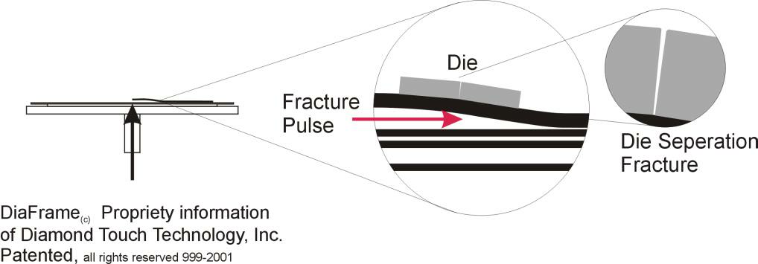
The Diaframe features are shown on the Diamond Touch web site www.diamondtouch.com and a visit will show how the Diaframe works. The Diaframe is mounted to our special vacuum chucks on the edges. A controlled “puff” of air below the center quickly raises the center of the Diaframe and the breaking propagates from the center to the edges in both axis at the same time. The die break repeatedly at the same spot to produce uniform die size and the Diaframe is expanded slightly to separate the die for pickup. The vacuum is released and the Diaframe becomes the transport to the next operation. For sensitive die, the Diaframe is suspended in a package so the die surfaces are not touched. At the customer site, a UV source is used to reduce the adhesion. Time and intensity determine the residual adhesion for the die bonder and its die elevation capability. A simple vacuum chuck can be used on the more sophisticated Surface Mount Pick and Place equipment to do Chip on Board die attachment or a Hover Davis wafer handler can supply chips to the Pick and Place and even do flip chips.
The Diaframe can produce productivity improvements with your current equipment and process. The change to scribe cuts using the Diaframe to finish the separation can produce major productivity and cost improvements. The scribe cut change still uses your existing equipment and no major tooling changes.
This method of breaking does not touch the top of the die for GaAs devices and MEMs structures.
The adhesive technology is such an improvement over the blue tape that we see many other applications for sawing. The adhesion is sufficient than many substrates that previously required wax to attach the product to a substrate, can be replaced with thicker sheets of the base Diaframe polymer. The Diaframe sheet is held by vacuum to the chuck for sawing and then placed on a UV source for complete release of the product without the contamination and mess of adding and then removing the wax.
Diamond Touch would offer to demonstrate their technology on your product. We offer the Diaframe advantage without changes in you major equipment and then hope you will consider our advanced equipment that will further enhance your process. Please contact me at CR Tech,LLC by phone or email or you can contact Diamond Touch directly from their Web site. We would be happy to explain further how this product can be applied to your specific process and get you started toward the savings potential Diaframe offers.

Sincerely,


Chuck Rabas
CR Tech, LLC
414-899-7590
CRabas@aol.com
www.CRTechLLC.com
Fax 262-377-2288 (auto switch)
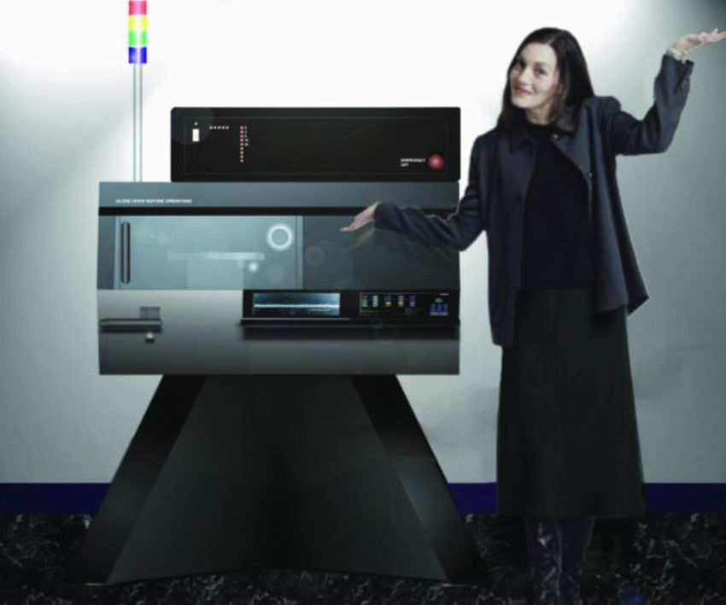

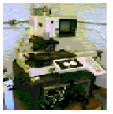

Re-engineered Saw

